ATTACHMENT 4: List of Equipment for System Test Platform and Accessories for Encryption Modification

6-Jan-25

Version: 0.2

System Test Platform to be a System

As NEW DESIGN CHANGE REQUEST,

TO DISCUSS!!

This Attachment is for new design change discussion, out of Scope

This Attachment takes reference to:

1. NCSIST SC12060P-CS移動臺等10項 工作說明書 (hereafter refers as SOW).
2. SOW Chapter 7.1 Encryption Verification Work Items密式驗證配合事項.

In accordance with SOW Chapter 7.1 item (3) and (4),

Item (3) - The manufacturer must provide the list and operation of the "System Test platform"

廠商須提供「系統測試平臺」清單及操作.

Item (4) - The manufacturer must provide a list and operations of accessory software, hardware and tools related to Encryption Modification 廠商須提供「密式置換相關附屬軟硬體及工具」清單及操作.

Following table illustrates list of Equipment for

System Test platform 系統測試平臺.

1. Accessory software, hardware and tools related to Encryption Modification 密式置換相關附屬軟硬體及工具.

System Test Platform as System

A New Design Change Request

To DISCUSS!!

|  |  |  |  |
| --- | --- | --- | --- |
| **List of Equipment for System Test Platform系統測試平臺 (套)** | | | |
| 項次 | Equipment Description | Quantity | Remark |
| 1 | DSC傳統通訊站台控制器（DSC8000） | 1 | Acting as Site controller to each GTR8000 site |
| 2 | 傳統通訊中繼台（GTR8000） | 1 | Acting as RF Signal relays |
| 3 | 交換器Switch | 1 | Acting as Ethernet packet exchange |
| 4 | 派遣台（MCC7500） | 1 | Acting as Dispatch Console for dispatch the calls |
| 5 | 其它細項 | 1 | Other supplementary equipment |
| **交貨數量：系統測試平臺共2套** | | | |

|  |  |  |  |
| --- | --- | --- | --- |
| **List of Equipment for Accessory software, hardware and tools related to Encryption Modification 「密式置換相關附屬軟硬體及工具」(套)** | | | |
| 項次 | Equipment Description | Quantity | Remark |
| 1 | Advanced Development Kit (ADK) | 1 | Note 2 |
| 2 | Configurable Parameter provisioning Tool | 1 | Note 3 |
| 3 | 筆電（用於容納 ADK與可設定參數服務開通工具）（由V＆V提供） | 1 | As Hardware platform for item:  #1 Advanced Development Kit (ADK)  #2 Configurable Parameter provisioning Tool |
| **交貨數量：密式置換相關附屬軟硬體及工具共2套** | | | |

Note:

1. Definition

Encryption Modification as 密式置換 in SOW.

Encryption Verification System as 密式驗證平臺 in SOW.

KMM Test Platform as the machine for verified KMM messages.

System Test Platform as 系統測試平臺 in SOW, a laptop machine installed with ADK and Configurable Parameter provisioning Tool.

1. **ADK** is an Arm Keil MDK software to verify the initial development of the indigenous algorithm. The project contains the main code for the customizable algorithm.
2. **The Configurable Parameters Provisioning Tool** is a software application that takes the values from the development kit and programs them (over RS-232) into the KVL ready for loading into a subscriber or infrastructure equipment that supports the customization.

**System Test Platform (STP) 系統測試平臺**

1. Figure 1 illustrates Encryption Verification System (EVP) 密式驗證平臺, mainly consists of VPM, KMF, 加密研改相關附屬軟硬體及工具and System Test Platform (STP) 系統測試平臺.
2. The System Test Platform (STP) 系統測試平臺 works as integral part of EVP, and through EVP and KMF, allowing mutual encryption/decryption tests on mobile, dispatch stations or network management centers and system connectivity encryption verification.

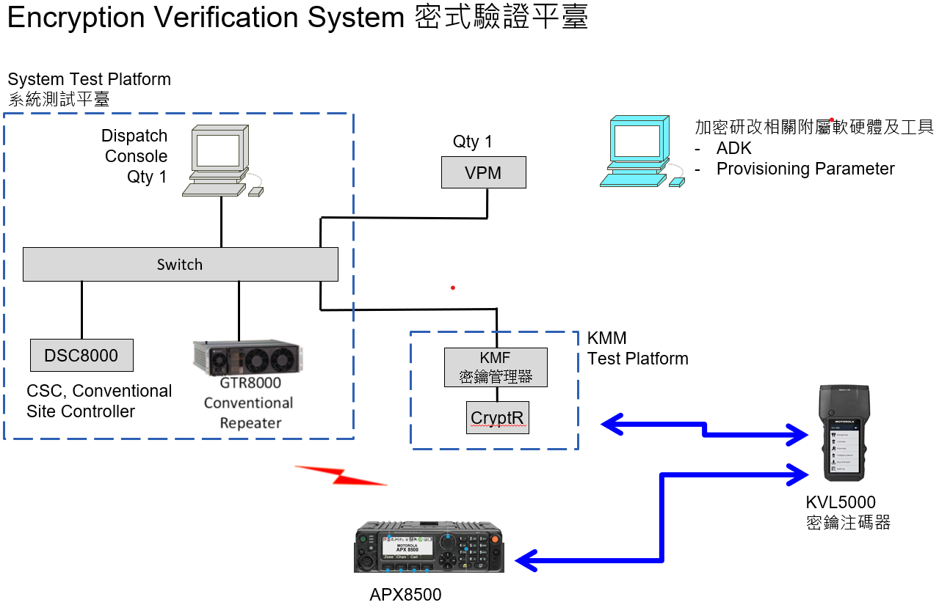

System Test Platform as System

A New Design Change Request

To DISCUSS!!

Figure 1 Encryption Verification System 密式驗證平臺

System Test Platform as System

As NEW DESIGN CHANGE REQUEST,

TO DISCUSS!!

This Attachment is for new design change discussion, out of Scope